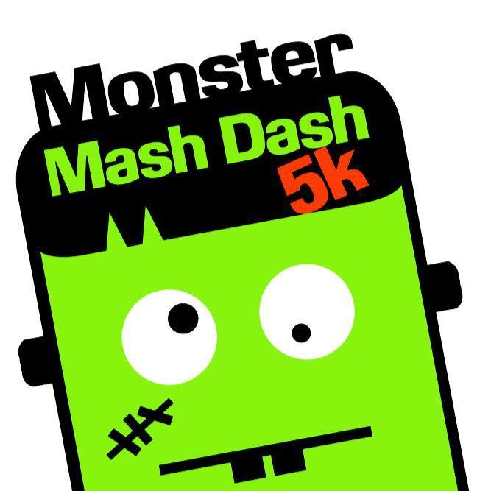Monster Mash Dash 5K and Fun Run
Leeds Elementary and Primary School
Leeds Elementary School
Oct. 29, 2016
Fun Run @ 8am
5K @ 9am
FUN RUN Permission Slip

The Leeds Elementary and Leeds Primary PTO are excited to announce that our students and their families are invited to participate in our third annual Monster Mash 5K and Fun Run on Oct. 29th. This year’s run will begin on 1st Avenue, across the street from Leeds Elementary. This year’s run is a combined fundraiser for both schools. Our goal is to educate our students about living a healthy lifestyle in addition to raising funds to go towards improving literacy and technology in both buildings.
The Fun Run is a one mile run and is for students in grades PreK-6 and will take place at 8am prior to the 5K beginning at 9am. Parents and siblings are welcome to run the one-mile course with your child. We do ask that parents with strollers stay at the end of the start line to give our runners a safe start. Below are the details for how to register and pay for the Fun Run. All monies and permission slips are due by Oct. 7th. This will give us ample time to get t-shirts ordered and delivered before the day of the race. Your child’s t-shirt will be sent home with them the week of Oct. 24th.

Event: Fun Run
Where: Beginning on 1st Avenue (across the street from LES)
Start Time: 8 AM
Cost: $15 for each student in grades PreK-6
A Monster Mash T-shirt for all student runners in grades PreK-6 is included in this registration fee.

There will be a $5 charge per parent and/ or siblings under PreK age who chooses to run with their student runner. T-shirt not included.

Please fill out the form below and return to your student’s teacher by Oct. 7th. The first 5 classes with 100% student participation will receive a pizza party. Students may wear their costume and invite friends and family to come cheer them on! If you would like additional forms for your friends and family to participate in the Fun Run please let your student’s teacher know.
Name(s) of student runner(s):

____________________________________________ Grade: _____ Teacher:________________________________

____________________________________________ Grade: _____ Teacher:________________________________

____________________________________________ Grade: _____ Teacher:________________________________

____________________________________________ Grade: _____ Teacher:________________________________

Total # of T-shirt needed for student runners: ____________ Total student runners X $15 = ________________
Size: Youth S_____ M____ L____ XL____

# of parents and/or siblings under PreK age running with student: __________________X $5 = _______

Emergency Contact Information

Name:_______________________________________________ Phone Number:____________________________

Parent/Guardian Signature

Make checks payable to Leeds ElementaryPTO and include phone number, child’s name and teacher name.

Waiver must be signed for registration to be complete.
1. ASSUMPTION OF RISK. IN CONSIDERATION OF THE ACCEPTANCE OF YOUR REGISTRATION AND PARTICIPATION IN THE EVENT, YOU ASSUME FULL AND COMPLETE RISK AND RESPONSIBILITY FOR ANY INJURY OR ACCIDENT WHICH MAY OCCUR DURING THE EVENT, WHILE YOU ARE ON THE PREMISES OF THE EVENT, OR WHILE YOU ARE TRAVELING TO OR FROM THE EVENT. YOU UNDERSTAND THAT PARTICIPATING IN THE EVENT IS HAZARDOUS, AND THAT YOU SHOULD NOT ENTER AND PARTICIPATE UNLESS YOU ARE MEDICALLY ABLE AND PROPERLY TRAINED. YOU ACKNOWLEDGE AND AGREE THAT THE EVENT MAY BE HELD OVER PUBLIC ROADS AND FACILITIES OPEN TO THE PUBLIC DURING THE EVENT AND UPON WHICH HAZARDS ARE TO BE EXPECTED. YOU ALSO ACKNOWLEDGE AND AGREE THAT PARTICIPATION IN THE EVENT CARRIES WITH IT CERTAIN INHERENT RISKS AND DANGERS THAT CANNOT BE ELIMINATED COMPLETELY RANGING FROM RISK OF MINOR INJURIES TO CATASTROPHIC INJURIES INCLUDING PERMANENT DISABILITY AND DEATH. YOU ARE AWARE OF AND ASSUME ALL RISKS ASSOCIATED WITH PARTICIPATING IN THE EVENT, INCLUDING WITHOUT LIMITATION RISKS OF PERMANENT INJURY OR DEATH DUE TO FALLS, OBSTACLES, CONTACT WITH OTHER PARTICIPANTS, ACTS OR OMISSIONS OF OTHER PARTICIPANTS, EFFECT OF WEATHER, TRAFFIC AND CONDITIONS OF ANY ROAD.
2.Representations. You represent and warrant that you are in good physical condition, are able to safely participate in the Event and have no medical condition that would make your participation in the Event more hazardous. You consent to medical care and transportation in order to obtain treatment in the event of injury to you and understand that this Agreement and Waiver extends to any liability arising out of or in any way connected with the medical treatment and transportation provided in the event of an emergency and/or injury. You understand that no medical care may be available, but if it is, you assume liability for any and all medical expenses incurred as a result of your participation in the Event, including, but not limited to ambulance transport, hospital stays, physician, and pharmaceutical goods and services. You agree to observe and obey all posted rules and warnings, to follow any instructions or directions provided to you by the Event organizer and to abide by any decision of any Event official relative to your ability to safely participate in or attend the Event. You understand and agree that you are expected to exhibit appropriate behavior at all times while at the Event and to obey all local, state and federal civil and criminal laws while participating in or attending the Event. This includes, generally, respect for other people, equipment, facilities or property. You agree that Event officials may dismiss you, without refund, should your behavior endanger the safety of or negatively affect the Event. You understand and agree that the Event organizer is not responsible for any personal item or property that is lost, damaged or stolen at the Event. You understand and agree that the Event organizer reserves the right to cancel the Event in the event of weather (including, but not limited to, heat, tornadoes, earthquakes, fires, storms, lightning and floods), accidents, acts of war or terrorism, military conflicts or riots or for any reason that would affect the safety and security of Event participants and spectators. In the event of such cancellation or any other cancellation for any reason, there will be no refund of your payment unless authorized and paid by the Event organizer.

Parent/Guardian Signature _____________________________________ Date:_______________

