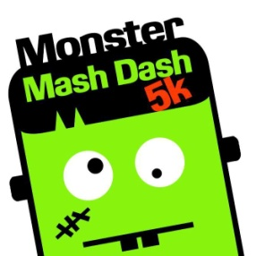
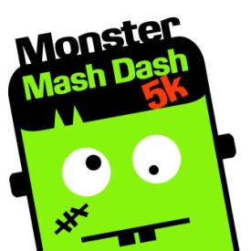
Monster Mash Dash 5K and Fun Run
Benefiting: Leeds Elementary School& Leeds Primary School
Oct. 29, 2016 @
Leeds Elementary School
950 Ashville Road Leeds, AL 35094
Fun Run @ 8am
5K @ 9am
Vendors 8am – 2pm

Dear Community Partner,
As a valuable member of our business community, the Leeds Elementary School (LES)& Leeds Primary School (LPS)PTO and staff would like to solicit your participation in an exciting event which we will be hosting this school year. Our third annual Monster Mash Dash 5K and Fun Run to be held Saturday, Oct. 29th at Leeds Elementary School. We are anticipating your company/organization’s participation in this community event!
In an effort to decrease health issues related to adult and childhood obesity within our community, the purpose of this event is to promote and model healthy living for our children, as well as, a PTO fundraiser with a specific goal. The specific goal is to increase the level of the hands-on technology within our school and literacy instruction for all students. Last year, we raised approximately $25,000. This year, our goal is $35,000.With your support, we believe we will meet our goal. Leeds Elementary and Leeds Primary School are determined to ensure that our children are technology literate and critical thinkers as they make well-informed choices utilizing the amazing world of technology.
SPONSORSHIP HAS ITS PRIVILEGES!! We are offering several sponsorship opportunities. While helping our students succeed in today’s highly technological world; your company will not just benefit from exposure to the Leeds community but to the Birmingham and surrounding communities, as well. There are several levels of sponsorship opportunities available to you. Please refer to the attached agreement for sponsorship instructions and agreement levels.
This year there will be a new element of fun for the entire family. We will have vendors. We are reaching out to our local business owners, craftsmen and entrepreneurs and asking if you would like to have your business represented at a booth the day of our Fun Run and 5k.
The events of the day will include the Fun Run for students in grades K-6 beginning at 8a.m. followed by a 5K beginning at 9a.m. Our vendors will be open from 8am – 2pm and will be located on the field behind Leeds Elementary School. We are expecting a large crowd of supporters, participants and vendors. Therefore, we are counting on you and your efforts of support to help make this day a success for the students of both, LES and LPS.
Please visit our website www.leedselementary.organd/or www.leedsprimary.org to learn more about this event; also, like us on Facebook. You may contact Ashley Isbell( aisbell@leedsk12.org ) or Reagan Tolbert(rtolbert@leedsk12.org ) if you have any questions.
Thank you in advance for your assistance in helping us meet our goal!We look forward to seeing you at the Monster Mash on Oct. 29th.

Thank you in advance for your support.

Leeds Elementary School Staff, Leeds Primary School Staff and PTO

Monster Mash 2016 Sponsorship Agreement Information
Yes, I will participate by becoming a sponsor, as indicated below.
_____ Gold Sponsor $3000 minimum
Company logo on the FRONT of the race shirts.
Logo on event banner outside school and at Leeds Elementary School the day of the race.
Logo on website with link to your corporate home page.
Company name included in publicity flyers.
Recognition the day of the race.
Thank you on LES/LPS website and school marquee.

_____ Silver Sponsor $2000 minimum
Logo on the BACK of the race shirts.
Logo on website with link to your corporate home page.
Company name included in publicity flyers.
Recognition the day of the race.
Thank you on LES/LPS website and school marquee.

_____ Bronze Sponsor $1000 minimum
Company name listed on the back of the race shirts.
Company name listed on our website as a sponsor.
Recognition the day of the race.
Thank you on LES/LPS website and school marquee.

_____ Honorary Sponsor$500 minimum
Company name listed on our website as sponsor.

Company Name:___________________________________________________________________________________________
Mailing Address: ___________________________________________________________________________
City, St, Zip: _______________________________________________________________________________________________
Contact name: _________________________________________________Position/Title: ______________________________
Contact Phone: ________________________________________________Email: ______________________________________
Date Submitted: ___________________________________________________________________________________________

$3000 (minimum) Gold Sponsor: _______________
$2000 (minimum) Silver Sponsor: _______________
$1000 (minimum) Bronze Sponsor: _______________
Honorary Sponsorship ($500 minimum) Amt: _________

Sponsor’s Signature Date

Check Enclosed #_____________ Make checks payable to Leeds Elementary PTO or Leeds Primary PTO
- All donations are tax deductible. You will receive an acknowledgement from either the LES or LPS office for your tax records. Please email your company logo to aisbell@leedsk12.org or rtolbert@leedsk12.org

Please return completed form and donation to:
Monster Mash Dash 5K and Fun Run
Monster Mash Dash 5K and Fun Run
Leeds Primary School
991 Park Ave.
Leeds, AL 35094
205-702-4206 for questions

Leeds Elementary School
Or
950 Ashville Rd.
Leeds, AL 35094
205-699-4500 for questions

